
Final Year Project Report

Presented

by

Muhammad Adnan Shafiq
EE13/035

Hamza Zuberi

EE13/144

Ehtesham Ali Khan

EE13/081

Supervised by
Dr. Sheikh Muhammad Farhan

CASE Islamabad

In Partial Fulfillment of the Requirement for the Degree of

Bachelor of Science in Electrical (Computer) Engineering

DEPARTMENT OF ELECTRICAL ENGINEERING

Center For Advance Studies In Engineering ,

ISLAMABAD

May 2017

FPGA Based Out of Band Encryption Module with Key Management System

Declaration

We, hereby declare that this project neither as a whole nor as a part there of has been copied out from any source. It is further declared that we have developed this project and the accompanied report entirely on the basis of our personal efforts made under the sincere guidance of our supervisor. No portion of the work presented in this report has been submitted in the support of any other degree or qualification of this or any other University or Institute of learning.

Signature:______________
Name Muhammad Adnan Shafiq

Signature:______________

Name Hamza Zuberi

Signature:______________

Name Ehtesham Ali Khan

Final Approval

FPGA Based Out of Band Encryption Module with Key Management System

Bachelor of Science in Electrical (Computer)Engineering

by

Name Registration Number

Muhammad Adnan Shafiq EE13/035

Hamza Zuberi EE13/144

Ehtesham Ali Khan EE13/035

has been approved for

Center For Advance Studies in Engineering,
ISLAMABAD

_____________________
Supervisor

Name, Designation

______________________ ______________________
Internal Examiner-1 Internal Examiner-2

Name, Name,
Designation Designation

______________________
External Examiner

Name,

Designation

_____________________
Head

Department of Electrical Engineering
Dedication
We dedicate this project to our supervisor, our parents and our teacher

List of Acronyms

AES…………………………………..Advanced Encryption Standard
DES………………………..................Data Encryption Standard
NIST………………………................ National Institute of Standards and Technology

FPGA………………………...............Field Programmable Gate Arrays
IC……………………….....................Integrated Chip
LSI……………………………………Large Scale Integration
RAM………………………………… Random Access Memory
UART………………………………..Universal Asynchronous Receiver Transmitter
NIST ………………………………….National Institute of Standard and Technology
OS……………………………………..Operating System

Abstract
As we know security is most important part in data communication system .Todays technologies have introduced different methods and scheme to secure financial transaction and other mode of data exchange out-of-band is another such mode where authenticity of user is determine by using concept of “what you have ” this concept can be witnessed in one form by receiving pin codes on your registered cell phones to enable financial transaction making it truly out of band authentication

Contents
1 Chapter-1 10
1.1 Overview 10
1.2 Objectives 10
1.3 Problem Statement 10
1.4 Features 11
1.5 Beneficiaries of the Project 11
1.6 Block Diagram of Project 12
2 Chapter 2 13
2.1 Available interfaces 13
2.2 Available memory modules 13
2.3 C# Application 13
2.4 Working of C# Application 14
2.5 Simulation 14
2.6 Features off application 15
2.7 UART Transmitter 15
2.7.1 Port 15
2.7.2 RTL diagram of UART transmitter 16
2.7.3 State Machine of UART transmitter 17
2.8 UART Receiver 18
2.8.1 Port 18
2.8.2 RTL Diagram of UART Receiver 19
2.8.3 State Machine of UART Receiver 20
3 Chapter 3 21
3.1 Phase-1 Overview 21
3.2 Introduction to AES Algorithm 22
3.2.1 Modern AES and Applications: 22
3.2.2 Confidentiality 22
3.2.3 Integrity 22
3.2.4 Authentication 23
3.2.5 Non-repudiation 23
3.3 History of AES 23
3.4 AES Vs. DES (A comparison) 24
3 Rijndael Algorithm 25
3.1 Introduction 25
3.2 Definitions 25
3.2.1 Glossary of terms 25
3.3 Block cipher 26
3.4 Encryption process 27
3.4.1 Step 1: Plain text 27
3.4.2 Step 2: Encryption Round 28
3.4.3 Step 3: Cipher text 29
3.5 Decryption Process 29
3.5.1 Step 1: Cipher text 29
3.5.2 Step 2: Decryption Round 30
3.6 Step 3: Plain text 30
3.7 Implementation of AES on Verilog 31
3.7.1 Introduction of Xilinx 31
3.7.2 What is Xilinx ISE 31
3.7.3 Why Xilinx ISE 31
3.7.4 Working 31
3.7.5 Xilinx ISE Design Flow 31
3.8 Steps in Xilinx 31
3.8.1 Design creation 31
3.8.2 Synthesis 31
3.8.3 Simulation 32
3.8.4 Constraints entry 32
3.8.5 Implementation 32
3.8.6 Implementation analysis 32
3.8.7 Generation of programming file 33
3.9 Verilog 33
3.9.1 Definitions of constants 33
3.9.2 Why Verilog 33
3.9.3 Modules 33
3.10 Algorithmic functions 34
3.11 Notations 34
3.11.1 Inputs and Outputs 34
3.11.2 Bytes 34
3.12 Process of Encryption 34
3.12.1 Aes_round() 34
3.12.2 Evolve key 35
3.12.3 Sub_byte 36
3.12.4 Mix_column 37
3.13 RESULTS 37
3.14 Implementation of AES on C++ 39
3.15 RTL Diagram of AES algorithm 40
4 Chapter 5 41
4.1 Overview of phase-3 41
4.2 Overview of architecture design 41
4.3 Architecture Design of Project 42
4.3.1 Instruction Table 43
4.4 Chipscope Pro 44
4.4.1 Cores 44
4.4.2 ILA 44
4.4.3 ATC2 44
4.4.4 VIO 44
4.4.5 Run time Debugging on Chipscope Pro 45
4.5 Memory Interface Generator 46
5 Chapter 6 51
5.1 Phase 4 overview 51
5.2 RSA algorithm 51
5.2.1 Application of public key cryptosystem 51
5.2.2 Description RSA Algorithm 51
5.2.3 Encryption 52
5.2.4 Decryption 52
5.3 Implementation of RSA Algorithm 52
5.3.1 Steps 52
5.3.2 Generation of Public Key 53
5.3.3 Encryption 53
5.3.4 Decryption 54
6 Chapter 6 54
6.1 Overview of 54
6.2 Testing and Integration 54

Chapter-1
Introduction

Overview

The title of project is “FPGA based out of band encryption module with key management system .Our project has four phases
    - Phase1
- Full understanding of digilient FPGA board
- USB to UART bridge prototype
- C# application development

    - Phase2
- Understanding of AES algorithm
- Implementation of AES on C++
- Implementation of AES on Verilog

    - Phase3
- Implementation of architecture design
- Chipscope pro
- Memory Interface Generator(MIG)

    - Phase4
- Key Management System

    - Phase 5
- Testing and integration

Objectives

Encryption is widely use in defense area where confidential data have to send or receive securely but our operating system (OS) are made by other countries and they have some channels in our OS through which they can attack our system and can easily acquire personal information. But concept of KMS make encryption algorithm more secure it did not depends on our OS which

Problem Statement

Our purpose is to develop out of band encryption module with KMS to secure network to the maximum. This is achieved using FPGA. Without FPGA, network is less secure, more costly and uses more area. Hardware implementations are important in order to achieve maximum security against attackers or spies. We are using AES Rijndael cipher using FPGA in order to accomplish a low cost implementation of AES. We are developing C# application and interface with FPGA using UART and also making our own KMS

Features
- Efficient architecture design
- AES 256 bit algorithm
- User friendly C# application
- DDR2 RAM interface
- Key Management System
- Not depend on our operating system

Beneficiaries of the Project
Our system will work as plug & play and will be integrated to the security information systems already in use. It will be usable equally for small as well as large organizations and local public. Different security organizations either locally or globally can be benefited from this project .The easiest customers to be attracted to our system will be among those security organizations and local public

Block Diagram of Project

Figure 1 Block diagram

Chapter 2
Phase -1

Available interfaces
- JTAG interface
- SPI interface
- UART interface
- Master BPI interface
- Ethernet interface
- HDMI interface

Available memory modules
- DDR2 RAM 1GB(64MBx16)
- BRAMS each block RAM depth is 16KB and 16 BRAM are available
- On Board Oscillator
- 100MHZ

C# Application
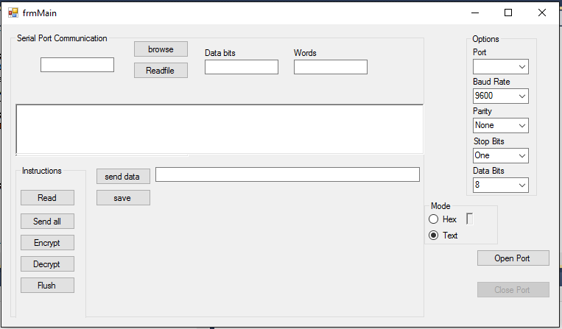
Figure 3 C# application

Working of C# Application

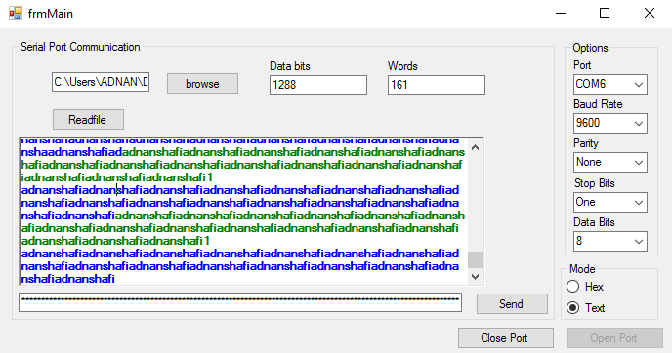

Figure 4 working of c# application
- Data in green color show sending data to FGPA data bits show no of bits send to FPGA
- Data in blue color show receiving data from FPGA

Simulation

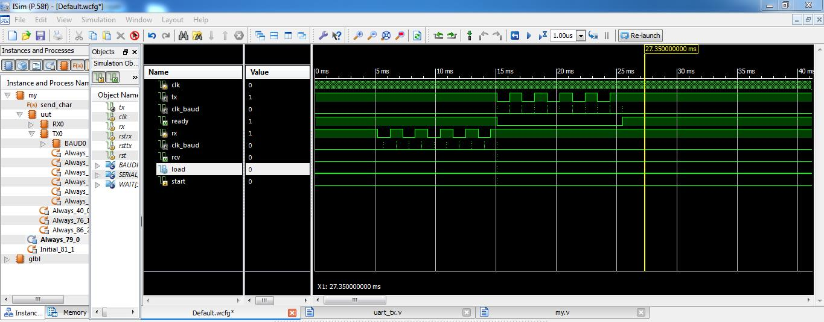
Figure 5 simulation

Features off application
- Select port
- Open port button open selected port
- Read any type of file from directory
- Send button send read file to FPGA
- Encrypt button encrypt read file
- Decrypt button decrypt encrypted file
- Flush button flush memory’
- Save button save decrypted file into respective format

UART Transmitter

Port
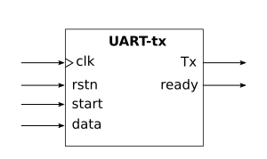
Explanation
- Inputs:
  - clk: System clock
  - rstn: Active low. When rstn is 0, the serial unit is reset (synchronous reset)
  - start: Start the transmission. When it is a 1, the character from the input data is captured and the transmission begins
  - data: 8-bit data to transmit
- Outputs:
  - tx: Serial output. The data is sent as a serial package. It is connected to the transmission line
  - ready: Transmitter status. When ready is 1, the unit is ready to transmit. A new character can be sent. when it is 0, the unit is busy transmitting the previous character.

RTL diagram of UART transmitter
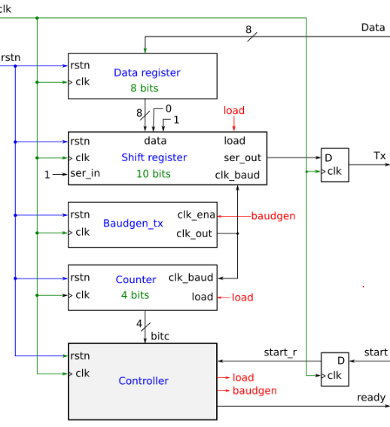
Figure 6 RTL diagram of UART transmitter
Explanation
- Data register (8 bits): For storing the data to be sent
- Shift registers (10 bits): For storing the serial package and sending its bits one by one. When the load signal is 1, it is loaded with a new character to transmit (8 bits). The two bits less significant are initialized with the binary value 01 (a start bit and a idle bit). When transmitting (load = 0), the less significant line is sent to the transmission line and then the register is shift right. A 1 is introduced in the most significant bit. It is only done when the clk_baud signal is 1. This signals determines the exact time when the next bit should be sent
- Baud generator: It generates a pulse of 1 cycle periodically, according to the baud rate configured
- Bit counter: It counts the bits that have already been transmitted. It only counts when load is 0
- controller: The finite state machine that generates the load and baudgen control signals for controlling the transmitter
- D flip-flops: There are two D flip-flops for registering both signals tx and start

State Machine of UART transmitter
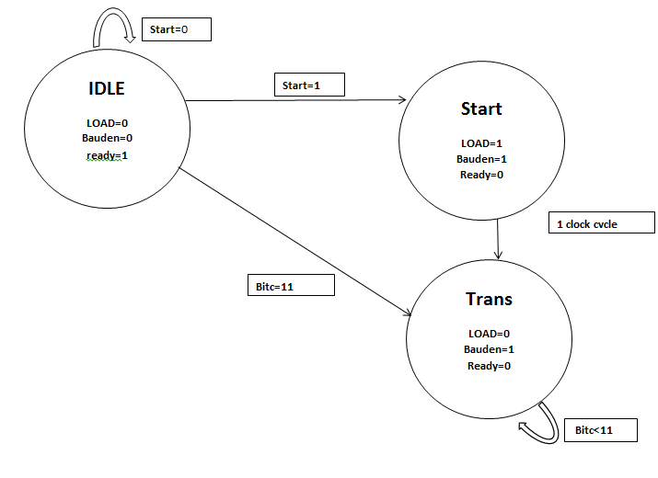
Figure 7 state machine of UART transmitter
FSM Explanation
- IDLE: There is no transmission. The unit is not being used. The ready signal is 1. When the start signal is set to 1, it changes to the START state
- START: The transmission is started. The shift register is loaded with the data to be send (plus the start bit). The baud generator is started. After one clock cycle it automatically moves to the next state
- TRANS: Transmission state. The 10-bits serial packages are sent. When the bit counter is 11, it means that 10 bits have been already transmitted and the state changes to IDLE

UART Receiver

Port
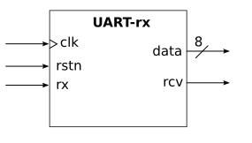
Explanation
- Inputs:
  - clk: System clock
  - rstn: Active low. When rstn is 0, the serial unit is reset (synchronous reset)
  - rx: Serial input. The serial packages are received from this input
- Outputs:
  - data: 8-bit data to transmit
  - rcv: Character received. When a new character is received, a pulse of duration 1 clock cycle is emitted, so that it can be used for capturing the data.

RTL Diagram of UART Receiver

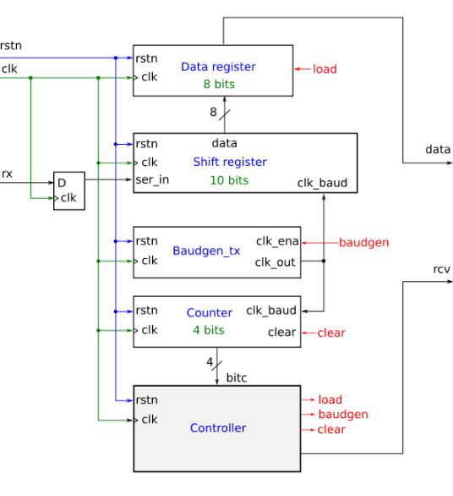
Figure 8 RTL diagram of UART receiver

Explanation
- Data register (8 bits): For storing the received character. It is captured when the load signal is active (1)
- Shift register (10 bits): For storing the serial bits received. Every bit is captured when the clk_baud signal is 1. This signal determines the exact time for sampling the incoming bits
- Baud generator: It generates a pulse of 1 cycle periodically, according to the baud rate configured
- Bit counter: It counts the bits that have already been received. It is reset to 0 when the clear signal is set to 1
- Controller: The finite state machine that generates the clear, load and bauden control signals for controlling the transmitter
- D flip-flops: For registering the rx input signal and get it synchronized

State Machine of UART Receiver

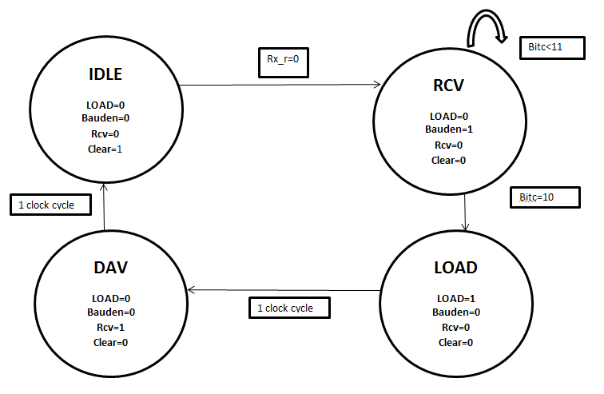
Figure 9 state machine of UART receiver
FSM Explanation
- IDLE: The unit is waiting for the start bit of the character. When it is received, it is changed to the RCV state. The bit counter is set to 0 (clear signal is 1)
- RCV: The baud generator is enabled and the bits are stored into the shift register. When a serial package (10 bits) is received, the state is changed to LOAD
- LOAD: Store the received data. The load control signal is activated (1)
- DAV: (Data available). A new data is available for reading. The signal rcv is set to 1 during one clock cycle

Chapter 3
Phase-2

Phase-1 Overview
Full understanding of AES algorithm
- Read FIPS AES 197 standard specification for the overall understanding of the algorithm
- Read other relevant material on AES and different modes of AES
Implementation of AES-256 in C/ C++
- Implement AES-256 in any of the languages
- Implement test bench for encryption and decryption of the data
- Use NIST validation test vectors for the verification of the implemented algorithm
Implementation of AES-256 in Verilog
- RTL diagrams of AES 256 bit key
- Implement AES-256 (256 bit key length, 128 bits block size) in Verilog
- Implement test bench for encryption and decryption of the data

Introduction to AES Algorithm

Modern AES and Applications:

The world is pacing towards digital technology faster and faster with each day. Electronic media and devices are a major part of our lives. People rely on wireless and wire networks for all big and small tasks. Things are becoming faster and efficient. But every picture has a brighter as well as a darker side. We are getting advanced but there is a side effect to it. It is becoming harder to protect data and to maintain privacy. Networks can be broken into; private information can be leaked etc. The solution to data leaks is cryptography. Cryptography is defined as:
Cryptography or cryptology is the process of securing data in a network in order to keep it private from third parties also known as opponents. Generally it can be described as a procedure that prevents a third person to gain access to specific information.
Cryptography is a part of cryptology and cryptanalysis. It included various techniques and algorithms through which data is protected. These techniques include combining words with images, microdots etc. in today’s world cryptography is used in almost all applications where secrecy is needed. These include ATM machines, passwords, secure communication.
Modern cryptography guarantees these four objectives, also termed as CIA:

Confidentiality

By this, it means that data will be confidential and secure in all ways. It cannot be accessed by a third party or person. It will stay between the sender and receiver

Integrity

The information sent or received will stay the same and cannot be changed. If however it is changed, sender and receiver will be notified.

Authentication

The sender and receiver will know beforehand who they are sending or receiving the information from. They will know of the origin and destination.

Non-repudiation

When sent or received, both parties cannot deny the existence or the authentication of the information.

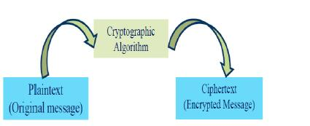

Figure 10 AES Algorithm

History of AES

AES is the predecessor of DES. It came into being after a long process, which lasted from, 1997-2000. It has many advantages over DES. AES is more secure way of protecting data as compared to DES because of its larger key size, which can be 128,192 and 256 bit. DES can only have the key size of 56 bit. A larger key size provides more rounds of encryption which means data is very hard to understand.
AES/ Rjindael became the official way of protecting data on November 2001 which was announced by NIST.
The first AES model was proposed by two Belgian cryptographers, Joan Daemen and Vincent Rijmen. The model that we use today is a better version of AES developed by Joan Daemen and Vincent Rijmen, which was evaluated by NIST during the selection.

4

AES Vs. DES (A comparison)

Following is a table where the main basic difference between AES and DES is given:

 | Data Encryption Standard | Advanced Encryption
 |  | Standard
Data | 1976 | 2001
Size of block | 64 | 128
Length of key | 56 | 128,192,256
Total round | 16 | 9,11,13
Encryption Radical | Substitution, permutation | Bit mixing, substitution ,
 |  | shifting.
Source | IBM, enhanced by NSA | Joan Daeman, Vincent
 |  | Rijmen.
Table 1 AES Vs. DES

The above table shows the basic difference between AES and DES. AES has over-take AES completely with its efficient ways.

Rijndael Algorithm

Introduction

A systematic block cipher algorithm that is chosen as the Advance Encryption Standard (AES), it’s a systematic algorithm to encrypt the key. It is a repeated block of cipher. The encryption and decryption of a data block is obtained by a series of repeated (rounds) of a specific transformations (round functions). Rijndeal generate a series of sub keys from the original keys, this generated subkeys are then used as input to the round functions.
Rijndeal is selected on the basis of these criteria
- Design simplicity
- Resistance against all known attacks
- Speed

Definitions

Glossary of terms

These definitions will be used throughout the standard
AES Advanced encryption standard
Affine transformation A transformation including multiplication matrix, Addition vector
Array Input/ output matrix of data bytes
Block Bits corresponds the input, output and keys.
Byte Array of 8 bits
Cipher Transformation that converts our plain text to cipher key
Cipher key Arrays of the bytes that have rows ‘I’ and columns ‘j’
Cipher text Data that we obtain from cipher or which is input to Inverse cypher

Inverse cypher Transformation that converts our cypher text to plaintext
Key expansion Module which is used to obtain round keys from cipher key
Plain text our input data
Round key Obtained from cipher key
S-box Substitution table that is used in byte substitution and in the key.
Word A group of 32 bits

Block cipher

Rjidael is a 128 bit cipher block which encrypts different block with variable key sizes. The data block and key size may be 128,192 or 256 bit. Rjindael encrypts data through a loop or rounds which can be 10, 12 or 14. Larger input or key size provides better protection. Similarly maximum rounds will protect data in a better way.
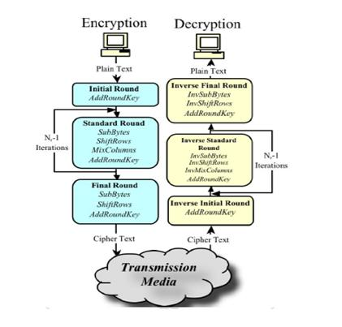

Figure 3.1 AES Algorithm

7

Encryption process

As we are using 128 but data using 128 bit key to encrypt data, all the following methods will be explained according to this.
The text which is our input data is called "Plain text" while the data which is obtained
after encryption is called "Cipher text". 128 bit data is being encrypted using Nr-1 loops. Loops can also be called rounds or iterations through which data is encrypted. Nr can be 10,12 or 14 depending on the key size.
Given below is the block diagram which will be explained later on:
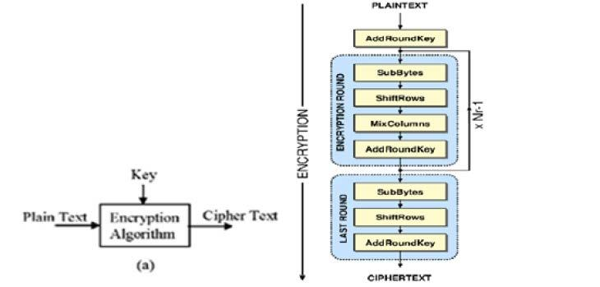

Figure 3.2 AES Encryption

Step 1: Plain text

The text which has to be encrypted is called plain text. The data which we will take is: (In hex)
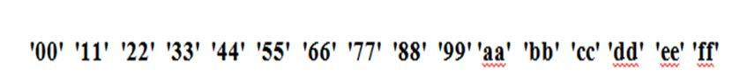

8

Step 2: Encryption Round

SubBytes

This is the first step towards encryption. It includes non-linear byte substitution which is operated separately on every bite. This substitution is done according to S-box. S-box is a box of 256 numbers from 0 to 255 which are pre-calculated.
The S-box in our case is the S-box in our case is:

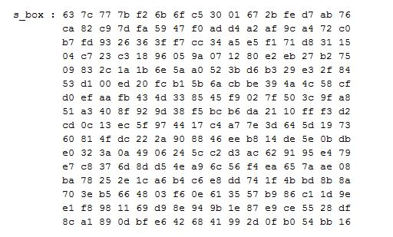

Figure 3. 3 S-Box

Given above is the s-box which we have used to decrypt data. The 128 bit is splitted into 16 discrete piece of 8 bits. Each of these bit is always used to address the Subst. box. The S-box has 256 bytes data entries.
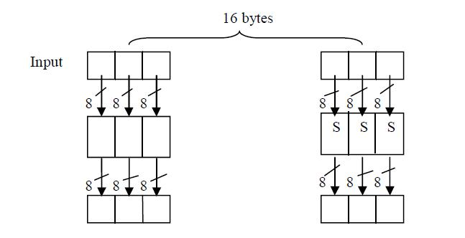

Figure 3.4 Parallelisms in AES

9

ShiftRows

In transformation of shift rows, we periodically shifted over different offsets. Row 0 is not shifted while row 1 is to be shifted over 1 byte, row 2 over 2 bytes and row 3 over three bytes

Mix Column

In the Mix-Column,we take different rows of data and mix them to form a new column the columns of the state are considered as polynomials multiplied by a fixed polynomial d(X), given by: d(X)='03'X3 + 'O1'X2 + '01'X + '02'. This Mix column transform can be written in a matrix form
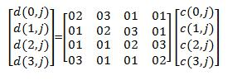

C is the input and D is the output of mix column which have lengths of 32 bits.

Add RoundKey

The next step after doing mix column is to apply round key to the state, which is done by doing XOR operations. The length of the round key will be equal to the length of this block.

Step 3: Cipher text

The text which is encrypted is called cipher text. The output after 10 rounds will be: (In hex)

Decryption Process

Step 1: Cipher text

The text which has to be decrypted is called plain text. The data which we will take is: (In hex)

Step 2: Decryption Round

InvByteSub

This transformation is done using a once-pre-determined substitution table called inverse S-box. This table contains 256 numbers and their corresponding values.

InvShiftRow

In this process, the rows of the state are periodically right shifted over different offsets. Each row is shifted by its row number. For example, row 0 is not shifted, row 1 is shifted one byte and so on and so forth.

InvMix-Column

In InvMix-Column, the columns of the state are considered as polynomials multiplied by a fixed polynomial d(x), given by: d(x)='OB'x³ + 'OD'x² + '09'x + 'OE’. The InvMix-Column transformation can be written in a matrix multiplication as follows:
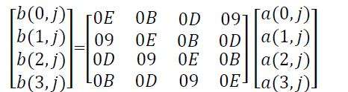

Inv-Add RoundKey

The round key is applied to the state resulted from the operation of inverse Mix-Column is done by bitwise inverse X-OR. The round key length and clock length are same.

Step 3: Plain text

The output after 10 rounds will be: (In hex)
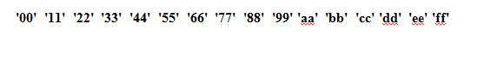

Implementation of AES on Verilog

Introduction of Xilinx

Xilinx is an American company which is famous for inventing FPGA. The FPGA (vertex 6 ML065) that we are using is invented by Xilinx company that have their own tools to program these FPGAs. We use these tools to program our FPGAs by connecting them with our laptops or personal computers.

What is Xilinx ISE

Xilinx ISE (integrated synthesis environment) is a software that is made by Xilinx for analysis and synthesis Verilog, VHDL or different languages based codes. It enable the programmer to compile their designs, perform analysis to simulate a design and then configure the FPGA with the programmer.

Why Xilinx ISE

Xilinx ISE is used for circuit designs. It is tightly coupled to the architecture of such chips and cannot be used from other vendors. we can program our FPGA with this tool easily it is easy to implement.

Working

Xilinx ISE Design Flow

Its design flow perform action in following pattern

- Design creation

- Synthesis

- Simulation

- Constraints

- Implementation

- Implementation analysis

- Generation of programing file

- Program FPGA

Steps in Xilinx

We have implemented our design on Xilinx by passing through different steps as mention above.

Design creation

In this step we have to create ISE project and then add different source files to that project. We have created different source files according to our design need.

Synthesis

The synthesis engine compiles our design to transform Verilog sources into an architecture design.

Simulation

we can verify functionality of our designs at various points during the design process.

Constraints entry

We can specify placement, timings and the other designing requirements.

Implementation

After doing synthesis we run design implementation, which converts the logical design into a physical file format that can be downloaded to our selected target device. Using the Project Navigator Design Goals and Strategies, we can modify process properties to control the implementation and optimization of the design. To attempt to meet your design goals faster, you can use SmartXplorer to automate multiple implementation runs with different process properties.

Implementation analysis

After implementation, we have to analyze our design for performance against constraints, , timing performance, device resource utilization and power utilization. We can view results in static report files and by looking at actual device implementation in graphical layout tools, such as the PlanAhead software and FPGA Editor. we can interactively analyze timing and power

results using the Timing Analyzer and XPower Analyzer tools. And, you can perform in-system debugging using the ChipScope Pro tool.

Generation of programming file

After generating the program file we can configure our FPGA. During configuration, we generate configuration files and download the programming files which is a bit file from our host computer to a FPGA.

Verilog

A Verilog configuration comprises of a chain of importance of modules. Modules epitomize outline pecking order, and speak with different modules through an arrangement of announced info, yield, and bidirectional ports. Inside, a module can contain any blend of the accompanying: net/variable presentations (wire, reg, whole number, and so forth.), simultaneous and successive proclamation pieces, and cases of different modules (sub-chains of importance). Consecutive articulations are set inside a start/end square and executed in successive request inside the piece. Notwithstanding, the pieces themselves are executed simultaneously, making Verilog an information stream dialect. Xilinx transfer this Verilog source into net list which is the connectivity of electric circuits

Definitions of constants

Addition of the parameter is defined by the constants in Verilog. As shown below

Width in bits-base letter-number

Example

- 24'h564321 ---- Hexadecimal 5654321 (24 bits)

• | 10'd22 | ---- Decimal 22 | (10 bit)
• | 7'b1111010 ----Binary 1111010 |  | (7 bits)
• | 7'o17 | ---- Octal 17 | (7 bits)

Why Verilog
We have chosen Verilog language to program FPGA because Verilog was much more popular for larger ASIC designs, which had performance and capacity demands on their simulations that FPGA designs did not. So geographical areas where ASIC design was more popular will also be where Verilog will be more popular.

Modules

We have made different modules to make our code simpler and easy to understand
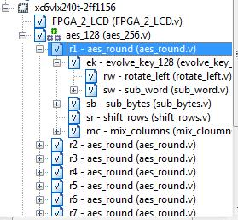

Figure 3.5

Algorithmic functions

The following functions are used to describe the code

Aes_round:: a complete round of key expansion, byte substitution Shift rows and mix coloumns

Evolve_key:: By XOR operations to add key in the state

Sub_byte:: conversion in to the cypher by using substitution table (S-box).

Mix_column:: it take all the columns of the state and mix them to Generate new column which is the cypher

Notations

Inputs and Outputs

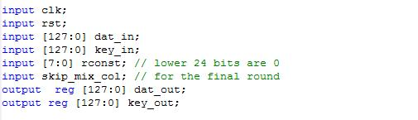
There is 128 bit of input data and also 256 bit of input key with one input of clk and reset. And then it gives 128 bit of output data in the form of plain text that will obtain after decryption

Bytes

All bytes values in this algorithm will be in the form of this pattern {b0, b1,b2,b3……b32}

Process of Encryption

We have done encryption by these modules. Each module has its own working

Aes_round()

Its main function which includes the entire process of one round. It includes the following sub modules.

- Evolve_key

- Sub_bytes

- Mix_column

Number of rounds depends on the length and block sizes.

AES-128 10-rounds

AES-192 12-rounds

AES-256 14-rounds

Evolve key

Algorithm which take cypher key to obtain a key schedule after performing key expansions which is stated earlier

It has further two modules1

Rotate_left

It takes a word as an input and perform cyclic permutations and return the word
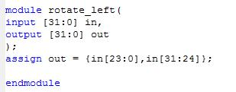

Figure 3.6

Sub_word

its a function that takes four bytes of input word and applies the S-box to each of the four bytes to produce an output word.
It has 32 inputs and 32 outputs
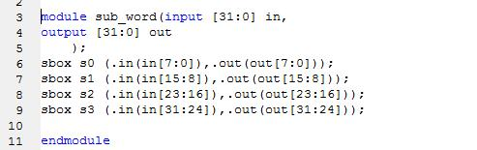

Figure 3.7

Sub_byte

The SubBytes() transformation is a byte substitution that operates on each byte of the state using a substitution table (S-box), which is invertible, is constructed by composing two transformations:

- Take the multiplicative inverse

- Apply the affine transformation

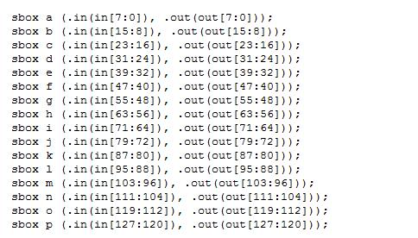

Figure 3.8

Mix_column

It operates on the state column by column by treating each column as a polynomial. It has 32 inputs and 32 outputs. By XORing the columns it generate a new column and return it back
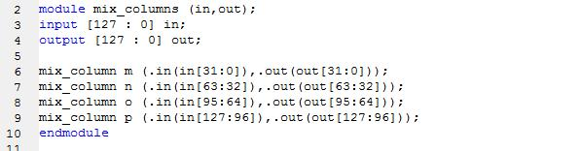

Figure 3.9

RESULTS

Plain text=128’h00112233445566778899aabbccddeeff
Cipherkey=256’h000102030405060708090a0b0c0d0e0f101112131415161718191a1b1c1d1e1f
Cipher text=128’h 8ea2b7ca516745bfeafc49904b496089
INPUT
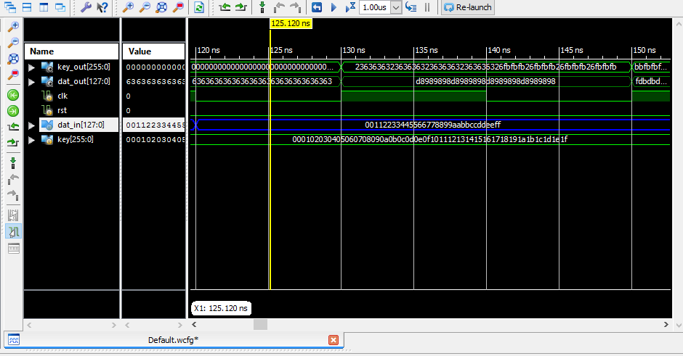
Figure 3.10

OUTPUT
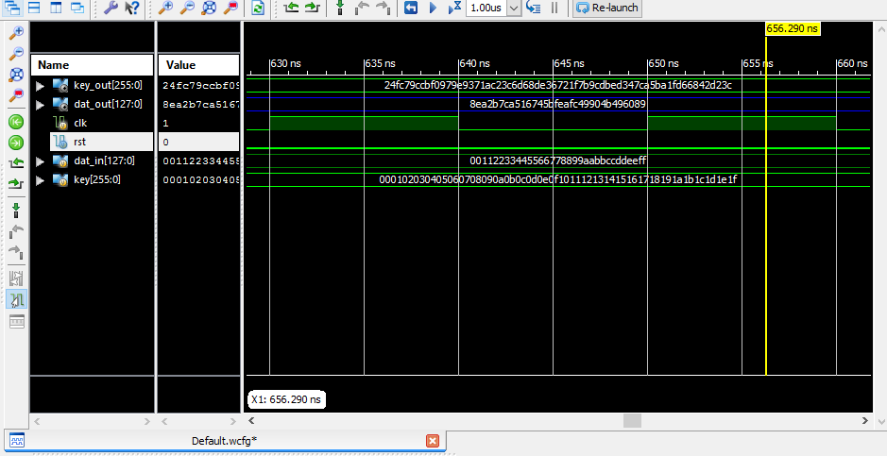
Figure 3.11

Implementation of AES on C++

- Plain text=128’h00112233445566778899aabbccddeeff
- Cipherkey=256’h000102030405060708090a0b0c0d0e0f101112131415161718191a1b1c1d1e1f
- Cipher text= 128’h 8ea2b7ca516745bfeafc49904b496089
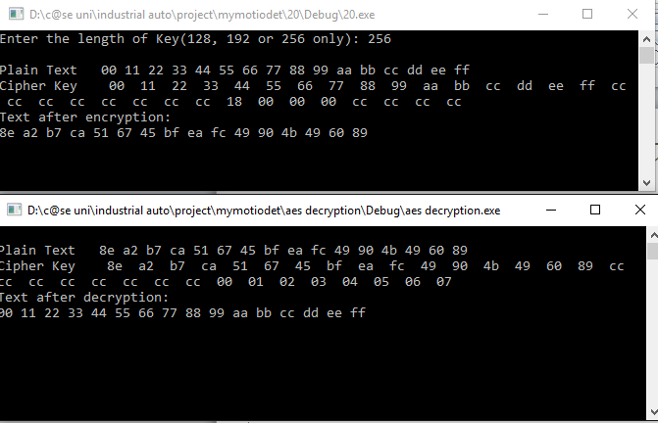

Figure 3.12

RTL Diagram of AES algorithm

Figure 3.13
Explanation
- Evolve Key module: it contain 3 module rot_left , subword and xorr its inputs are 256bit key ,8 bit rcon value and choice which is control by multiplexer and output is 256 bit key_out
- Sub_bytes:it can sbox module which take 8 bit input and provide 8 bit output
- Shift_rows:it take 128bit input and after shifting give 128 bit output
- Mix_coloum:it take 128 bit and give 128 bit output
Aes_round :it contain evolve_key, sub_bytes, Shift_rows, mix_coloum it take input key_in 256bit,data_in 128bit ,clk, rst, rcon,choice parameterand provide output key_out, data_out

Chapter 5
Phase 3

Overview of phase-3
- Architecture Design
- Chipscope pro
- Memory Interface Generator

Overview of architecture design
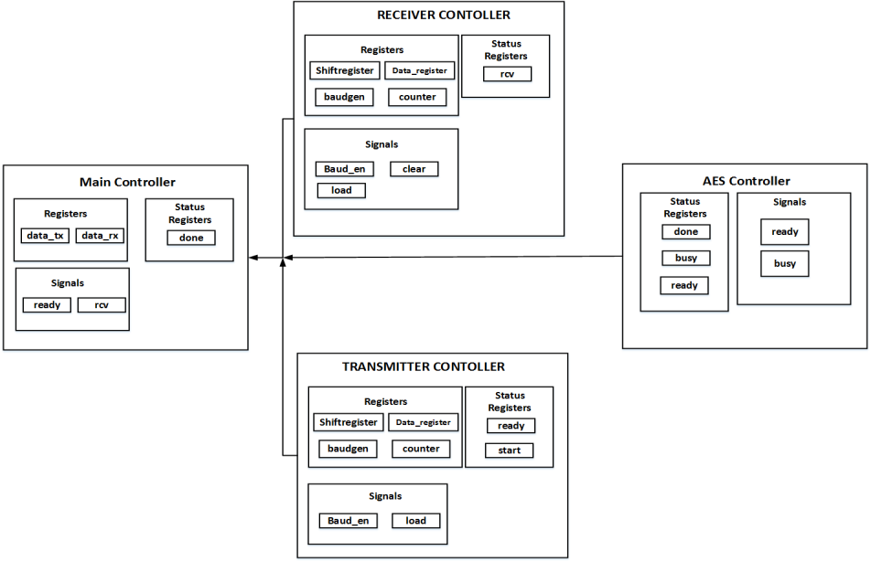

Figure 5.1

Architecture Design of Project
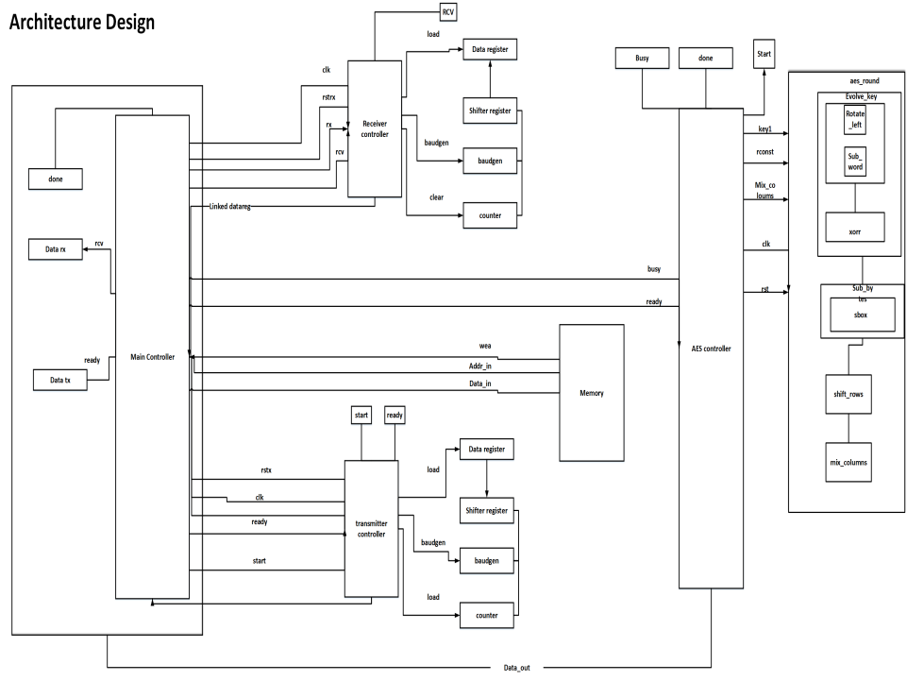

Figure 5.2

Explanation
- Architecture design of project contain 4 Controller main controller, aes controller, receiver controller, transmitter controller, and one DDR2 ram
- Receiver controller receive data from c# application and send rcv signal to main controller main controller receive data from receiver controller in datarx register
- Main controller store data to DDR2 RAM and also check signals from AES controller i.e aes controller is busy or done encrypting or decrypting data
- In AES controller if aes is busy then main controller will not read data from memory if aes done signal is 1 in main controller then main controller read data from memory and send to aes controller
- Aes controller encrypt/decrypt data and store data in memory
- Main controller read decrypted data and check status of transmitter controller if it is ready then send data to transmitter controller and transmitter controller send data to C# application

Instruction Table

Instruction | Signals | Status register | Data register
00000000  Memory status | rcv=1 | empty  full | data_rx=00000000
00000001  Receive data | rcv=1  wea=1 | rx_done  empty  full | data_rx=00000001
00000002  AES status | rcv=1 | ready  busy | data_rx=00000002
00000003  encrypted_data | rcv=1  data_out | ready | data_rx=00000003
00000004  Transmit data | rcv=1  ready | start | data_rx=00000004  data_tx=data to transmit

Chipscope Pro

Cores
ChipScope Pro allows you to embed the following cores within your design, which assist with on-chip debugging: integrated logic analyzer (ILA), integrated bus analyzer (IBA), and virtual input/output (VIO) low-profile software cores. These cores allow you to view internal signals and nodes in your FPGA

ICON
The Integrated Controller (ICON) core provides the communication between the embedded the IBA, and VIO cores and the computer running the ChipScope Pro Analyzer software.

ILA
The ILA core is a customizable logic analyzer core that can be used to monitor the internal signals in your design. Because the ILA core is synchronous to the design being monitored, all design clock constraints applied to your design are also applied to the components inside the ILA core.

ATC2
The Agilent Trace Core 2 (ATC2) is a customizable logic analyzer core, which is similar to the ILA core but does not use on-chip Block RAM resources to store captured trace data. The ATC2 core synchronizes ChipScope Pro to the Agilent FPGA dynamic probe technology, delivering the first integrated application for FPGA debug with logic analyzers.

VIO
The virtual input/output core is a customizable core that can both monitor and drive internal FPGA signals in real time. Unlike the ILA and IBA cores, the VIO core does not require on-chip RAM

Run time Debugging on Chipscope Pro
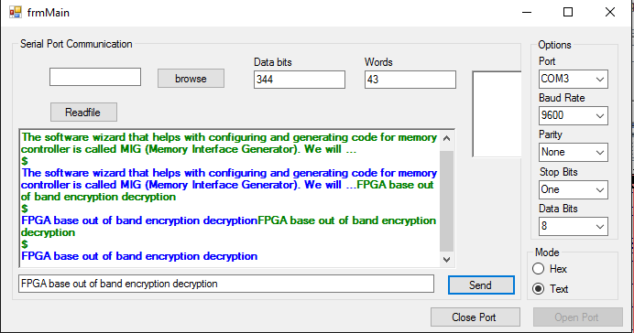
Figure 5.3
Send “FPGA base out of band encryption decryption”
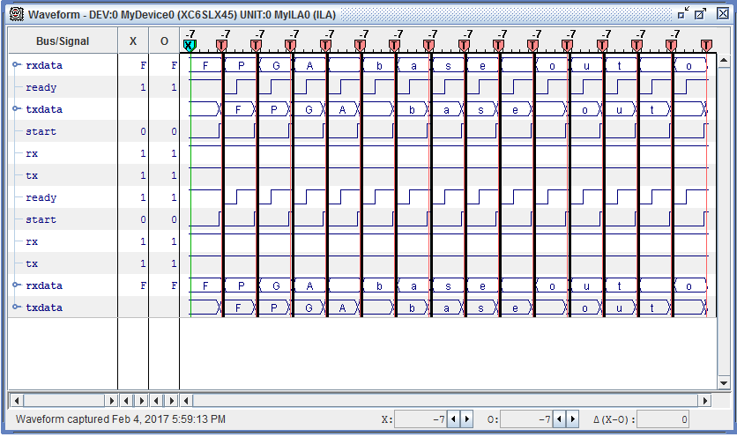
Figure 5.4
Rxdata and txdata registers show data on run time

Memory Interface Generator
  - On-chip block RAM and ROM
  - Frequently used for…
    - Finite State Machines
    - FIFO
    - Large/local data storage
- External memory for larger data storage
- Dedicated Memory Controller Block (MCB)
- Supports evolving controller standards
- All memory solutions
- Must be fast and flexible
- Bit stream can pre-loaded with fixed data for a ROM or RAM
- Easy to customize your memory controller and interface design
- Memory architecture, data rate, bus width
- CAS latency, burst length
- I/O bank assignments
- Generates RTL source code and UCF from hardware-verified IP
- Delivered as part of the ISE software (CORE Generator utility)
- MCB supports DDR, DDR2, DDR3, and LPDDR
- Soft Memory Controller supports other additional memory interfaces
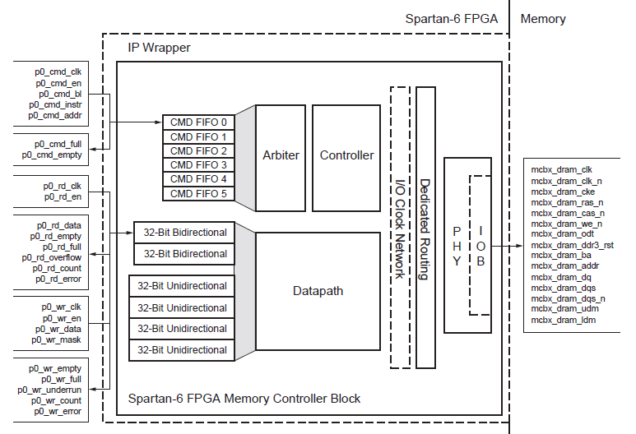
Figure 5.5
Explanation
- 128 bit bidirectional
- 8 burst mode
- Frequency 300MHZ dual clock

Commands
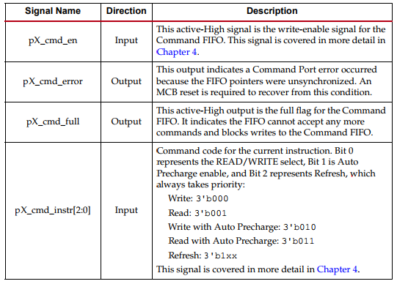
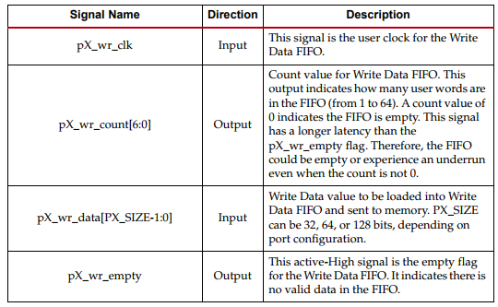
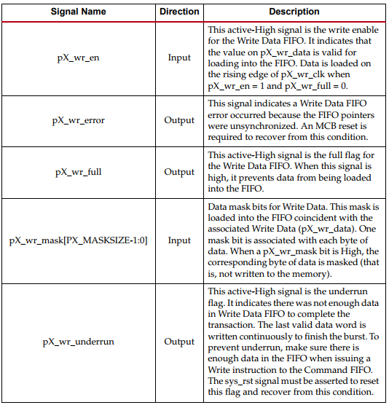

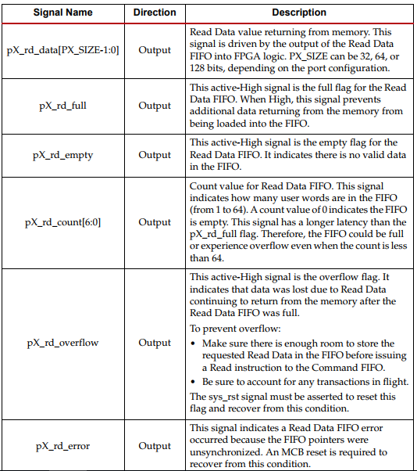

Chapter 6
Phase 4

Phase 4 overview
- Key Management System

RSA algorithm
Hellman, US cryptologists, invented in 1976 a method that addressed both problems, and that was radically different from all previous approaches to cryptography, going back over four millennia.

Application of public key cryptosystem
- Encryption/decryption
- Digital signature
- Key exchange

Description RSA Algorithm
RSA makes use of an expression with exponentials. Plaintext is encrypted in blocks, with each block having a binary value less than some integer n. Encryption and decryption are of the following form, for some plaintext block M and ciphertext block C:
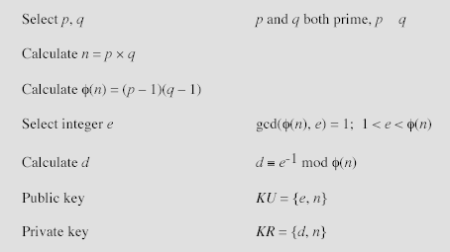

Encryption
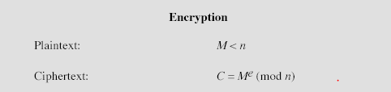

Decryption


Implementation of RSA Algorithm

Steps
- User first login by providing username and password ,public keys are assign to each user after they login
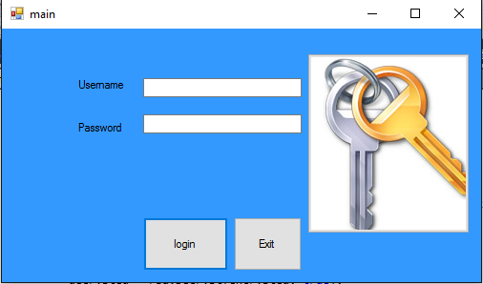
- Read Encrypted Private key (RSA+AES)from USB every
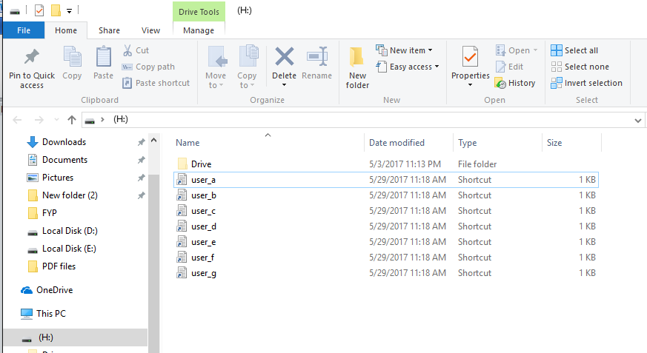
- User use public key and decrypt private key and send key to FPGA, key is still encrypted with AES algorithm so FPGA decrypt the key and send back original key to User

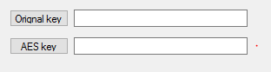

Generation of Public Key
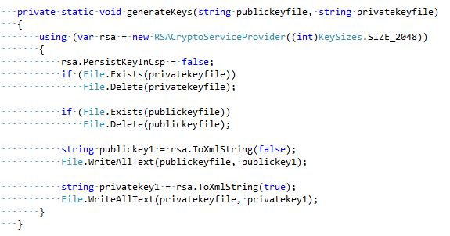

Encryption
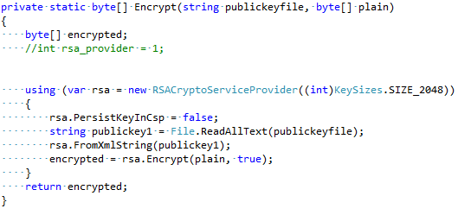

Decryption
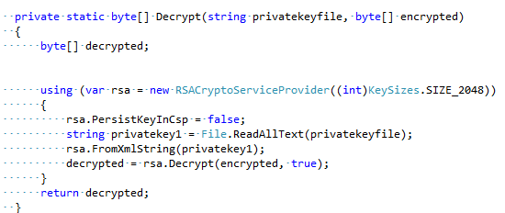

Chapter 6
Phase-5

Overview of
Testing and Integration

Testing and Integration
Read file “Assignment 3_2” from directory
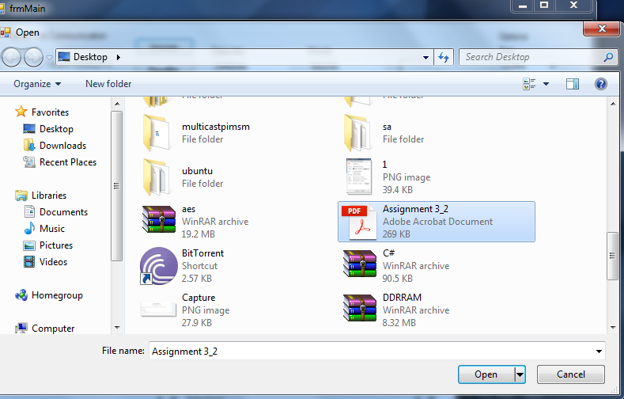
Figure 5.4
Send “2” instruction to FPGA which inform FPGA to get ready for encryption and then send read file to FPGA Encrypt file and decrypt and then send “3” instruction to FPGA and FPGA send decrypted data back to c# application which is represented in blue color
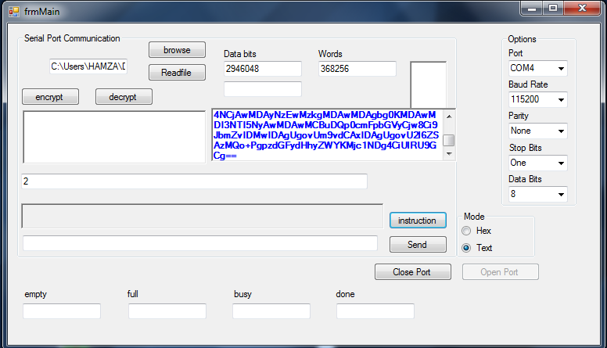
Figure 5.5
Application read decrypted data and save data in directory with name of “myfile2.pdf” So property of file before and after encryption/decryption is same

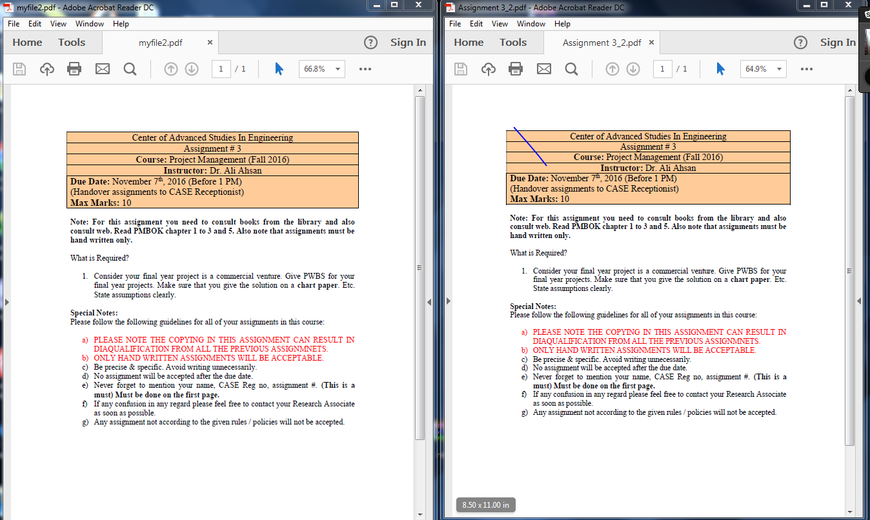
Figure 5.6
Both document before and after encryption and decryption remain same

